Startup

Plug the receiver to the PC com port. No power is required.
Place a transmitter around 1 meter away from the receiver.

From Start manual, select Programs -> Accessories -> Communications -> HyperTerminal

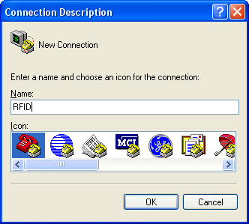

Enter a connection name, e.g. RFID

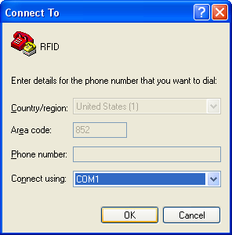

Select the com port name (Connect using) where you connected the receiver.
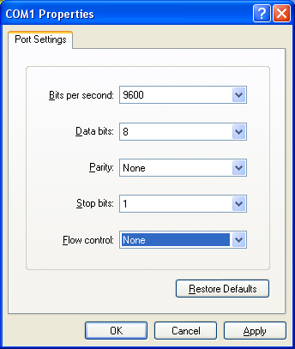

Bits per second MUST be 9600, Data bits MUST be 8, Parity MUST be None, Stop bits MUST be 1 and Flow control MUST be None.

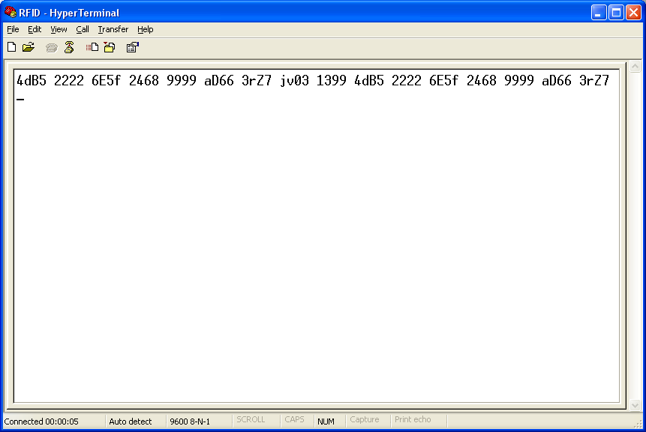

You should see the 4 characters codes and the same code will keep on coming up for every 2.5 seconds (not exactly 2.5 seconds, it is an intended design) if the transmitters are in range.
FAQ

Q1. Why the receiver has a DC 9V jet?
A1. The receiver is steeling the power from the PC com port. Most of the desktop PC can provide sufficient power for the receiver, however some notebooks or USB-to-Serial adaptors may not provide sufficient power. If you found the receiver cannot receive anything, try plug a DC 9V (center positive) to the receiver.

Q2. Will the deformed receiver antenna seriously lower down the effective radius?
A2. No. The supplied antenna is in a coil form. It will be working fine as long as it is vertical up (not necessary straight up). You can move it a bit to find out the best for your working environment. If you change the antenna to a 9 inches straight wire, our experiment shows that the effective radius can be double.

Q3. How can I increase the transmitter effective radius?
A3. Replace our enclosed coil form antenna with a 9 inches straight wire. The transmitter module, according to the manufacturer, can send signal up to 1,000 meters (but we never achieve this).

Q4. How can you know a CR2025 can power the transmitter for 5,000 hours?
A4. The transmitter will send out it’s unique ID for every 2.5 seconds. The transmitting time is 11 ms which will use 4mA. It will go to hibernation mode after the ID is transmitted. The circuit will use only 18 uA during hibernation. CR2025 capacity is 150 mAH. By using these figures a standard CR2025 can provide power for around 6,500 hours. We believe the worst scenario should no less than 5,000 hours.

Q5. I cannot receive anything when placing the transmitter next to the receiver.
A5. The receiver is using Superheterodyne design which cannot receive any signal generated by any close transmitter. This is a well know issue. If you place the transmitter 1 meter away from the receiver, it will be fine.

